For Healing After Abortion
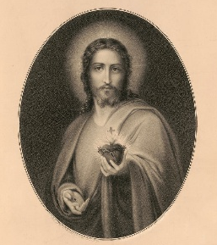
If you experience pain, guilt, or grief after abortion, be assured that God’s healing love and mercy are always available to the repentant heart.
For confidential, non-judgmental help, call (909) 475-5353 or (909) 520-3867 (Spanish). You can also send an email to: rachelhopeandhealing@sbdiocese.org

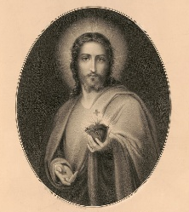
Healing After Abortion
Confidential, compassionate help is available.
Call (909) 475-5353 or
(909) 520-3867 (Spanish) to speak to someone who will listen and help.

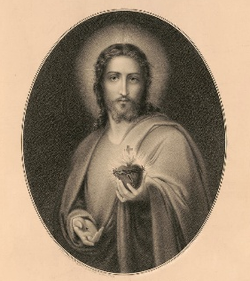
Healing After Abortion
Confidential, compassionate help is available.
Scan the code for more information and helpful resources.
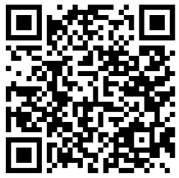
Visit: www.sbrlpc.org/post-abortion-healing

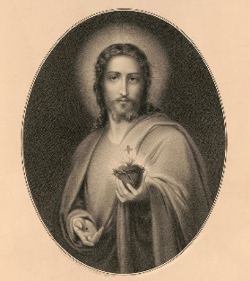
God heals and “never tires of forgiving us.” (Pope Francis)
If you feel as if God is far from you, be assured that He sees you and loves you. Find forgiveness, love, peace, and healing by calling (909) 475-5353 / (909) 520-3867 (Spanish). You can also send a confidential message to: rachelhopeandhealing@sbdiocese.org

Forgiveness and Hope After Abortion
Did fear and shame lead you or someone you know to have an abortion? Or you felt as if you had no other choice? Are you seeking comfort from welcoming, non-judgmental people to help you through your sadness and guilt? We invite you to make a confidential call to Rachel: Hope and Healing Ministry where you can connect with others who understand and can help. You’re not alone anymore. Peace and Healing starts here.
Call (909) 475-5353 / (909) 520-3867 (Spanish) or visit www.sbrlpc.org/post-abortion-healing for more information and help.

